IT633 Data Mining Lab  
Due Date: first class meeting after spring break (March 21, 2013)

**Overview**

In this lab, you will learn how a computer can automatically classify songs by genre through the analysis of the audio content. We provide a data set consisting of 150 songs where each song can be associated with one of the six genres.

Each song is represented by a bag-of-feature-vectors. Each 12-dimensional feature vector represents the timbre, or "color", of the sound for a short (less than one second) segment of audio data. If we think about each feature vector as being a point in a 12-dimensional timbre space, then we can think of a song being a cloud of points in this same timbre space. Furthermore, we can think of many songs from a particular genre as occupying a region in this space. We will use a multivariate Gaussian probability distribution to model the occupying region of timbre for each genre.

When we are given a new unclassified song, we calculate the probability of the song's bag-of-audio-feature-vectors under each of the six Gaussian genre models. We then predict that the genre with the highest probability. We can evaluate the accuracy of our Gaussian classifier by comparing how often the predicted genre matches the true genre for songs that were not originally used to create the Gaussian genre models.

**Objectives**

This lab approachs music genre classification as a standard supervised learning problem. Specifically, students will learn about:

1. important supervised learning concepts (training, evaluation, cross-validation)
2. the bag-of-feature-vector representation
3. Gaussian classifier
4. k-Nearest Neighbor classifier

You are not expected to do any audio signal processing as part of this lab. Sample Matlab and Python code is also provided on blackboard.

**Background Reading**

Many textbooks provide a general background material on supervised learning (e.g., Russell & Norvig's [AI: A Modern Approach](http://aima.cs.berkeley.edu/) and Duda, Hart & Stork's [Pattern Classifiation](http://books.google.com/books/about/Pattern_classification.html?id=YoxQAAAAMAAJ%22)). In addition, lots of information about supervised machine learning can be found on the web (e.g., Wikipedia).

For this lab in particular, below is a list of three good references related to content-based music genre classification:

1. [Echo Nest Analyze Documentation](http://modelai.gettysburg.edu/2012/music/docs/EchoNestAnalyzeDocumentation.pdf) - provides a background on how the timbre-based audio features are computed using digital signal processing. It also provides information about other available audio features related to rhythm, key, tempo, harmony and loudness.
2. [Music Genre Classification of Audio Signals](http://modelai.gettysburg.edu/2012/music/docs/tsap02gtzan.pdf) by Tzanetakis & Cook (2002)- a seminal work on the music genre classification problem. This paper is accessible to undergraduate AI students and provides them experience reading scholarly works.
3. [Exploring Automatic Music Annotation with Acoustically](http://modelai.gettysburg.edu/2012/music/docs/Tingle_Autotag_MIR10.pdf)-Objective Tags by Tingle, Kim, & Turnbull (2010) - a more recent music classification paper that connects the Tzanetakis paper with the Echo Nest audio features. This paper also serves as an example of how an undergraduate student researcher (Tingle) can make a contribution to the field of music information retrieval.

The main venue for music classification research is the International Society for Music Information Retrieval. If you are interested in reading more, the cummulative proceedings for 12+ years of research is online and publicly available for download.

**Details**

This lab can be done using any programming language, although Python (with the Numpy library) and Matlab have been found to work well.

***Step 1: Load up the Data***

In the [data/](http://modelai.gettysburg.edu/2012/music/data/) directory, you will find six subdirectories for six genres of music: classical, country, jazz, pop, rock, and techno. Each folder contains 25 data files for 25 songs that are associated with the specific genre. The relationship between a song and a genre is determined by social tagging and obtained using the [Last.fm API](http://www.last.fm/api/show/track.getTags).

The files are formatted as follows:

# Perhaps Love - John Denver

0.0,171.13,9.469,-28.48,57.491,-50.067,14.833,5.359,-27.228,0.973,-10.64,-7.228

26.049,-27.426,-56.109,-95.41,-40.974,99.266,-5.217,-18.986,-27.03,59.921,60.989,-4.059

35.338,5.255,-40.244,-14.309,32.12,30.625,9.415,-8.023,-27.699,-45.148,23.829,20.7

...

where the first line starts with a # symbol followed by the song name and artist. You can hear samples of most songs using Spotify, the Apple iTunes Store, last.fm, YouTube or any other music hosting site. Each following line consists of 12 decimal numbers that together represent the audio content for a short, stable segment of music. You can think of these numbers as a 12-dimensional representation of the various frequencies that make up a musical note or chord in the song. There are between about 300 to about 1300 segments per song. This number depends on both the length of the song (i.e., longer songs tend to have more segments), but also on the beat (i.e., fast vs. slow tempo) and timbre (e.g., noisy vs. minimalist) of the music. Below is a visual representation of how we can represent a song as a bag-of-feature-vectors:

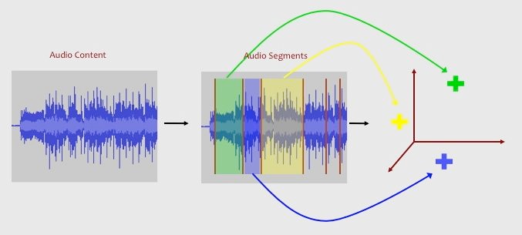

Your first step will be to load all 150 files into you program. The key will be to design a data structure that allows you to have access to each individual song's audio feature matrix (e.g, the time series of 12-dimensional audio feature vectors) as well as the metadata associated with each song (song name, artist name, genre).

**Before Moving On**: your program should load the audio feature matrices and associated metadata from the 150 data files*.*

***Step 2: Learning a Gaussian Distribution for each Genre***

For each of the 6 genres, you will want to randomly select 20 of the 25 songs to serve as a training set. (We will use the other 5 songs to evaluate the system in step 3.)

For each genre, you will need to calculate a 12-dimensional mean vector and a 12x12-dimensional [covariance matrix](http://en.wikipedia.org/wiki/Covariance_matrix). These 12+144 numbers fully describe our probabilistic model for the genre. (Note: If some genre were more common than other genres, we would have to store this additional information in the model as well. This is sometimes called the prior probability of a genre.) Below is a visual representation of how we can model the audio content from a set of songs using a Gaussian distribution:

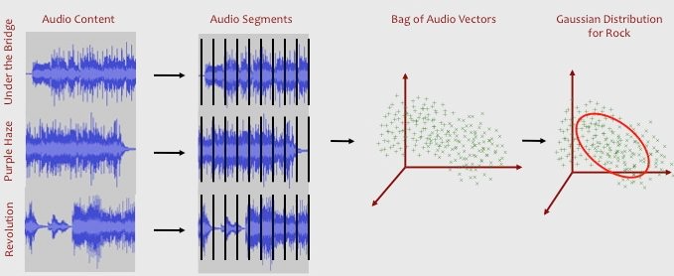

To start, we want to concatenate the audio features matrices for each of the 20 training songs. This is done by taking all of the rows from each of the feature matrices for the trainings songs associated with a genre and combining them into one large feature matrix. This will result in a large nx12-dimensional matrix where n will be between of 10,000 to 30,000 audio feature vectors (i.e., 20 songs times about 800 feature vectors per song.) You can then either use built-in math library functions to calculate the mean and covariance for this big data matrix or you can write the code from scratch. We will also want to use a built-in math function to calculate the inverse of the covariance matrix.

Note: Most programming languages (Matlab, Python-Numpy) have math libraries that provide useful mean, covariance, matrix transpose and matrix inverse functions. See the programming language documentation for details. To code these function from scratch, refer to an AI textbook, a statistics textbook, or Wikipedia for standard definitions of each concept.

**Before Moving On**: you should have one mean vector (12-dimensional), one covariance matrix (12x12-dimensional), and one inverse covariance matrix (12x12-dimensional) for each of the 6 genres.

***Step 3: Predicting the Genre of a Song***

We will combine the 5 remaining songs for each of the 6 genres into a 30-song evaluation set. For each of these songs, we will calculate the probability of the song's bag-of-audio-feature-vectors for each of the 6 Gaussian distributions that we trained in the previous step. More specifically, we will calculate the average unnormalized negative log likelihood (average-UNLL) of a song given a Gaussian distribution. While this might sound like a mouthful, we just want to find out how well the new song fits with each of the genre models that we learned from the training data. Below is a visual representation what we mean when we say "how good a new song fits a model":

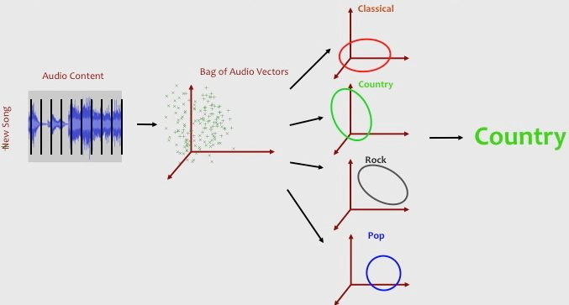

For each audio feature vector, the unnormalized negative log likelihood (UNLL) is:

UNLL = (x - mean_genre) * inverse(cov_genre) * transpose(x - mean_genre)

where x is the 1x12 audio feature vector, mean_genre is the 1x12 mean vector calculate in step 2, and inverse(cov_genre) is the 12x12 inverse of the covariance matrix also calculated in step 2. Finally, we then find the average UNLL for all of the audio vectors of the song.

Once we have calculated the average-UNLL for a song under each of the 6 Gaussian genre models, we simply predict the genre associated with the smallest average-UNLL value. If the true genre matches the predicted genre, we have accurately classified the song.

**Before Moving On:** You should calculate the average-UNLL for each of the 30 test set songs and each of the 6 genre models.

***Step 4: Evaluating Our Gaussian Classifiers***

The accuracy of our system is the percentage of songs that are accurately classified by our system. For the given data set, you should get about 55% accuracy. While this might seem low, random guessing would get us about 16% accuracy (i.e., 1/6 chance). Note that your performance might differ based on how we randomly split our data into training and evaluation data sets. If you were to re-run this experiment a bunch of times, you would see that the performance bounces around a bit. However, if we take the average accuracy for a number of random splits, we would be able to better estimate the true accuracy of our system. This process is called [random cross-validation](http://en.wikipedia.org/wiki/Cross-validation_(statistics)).

We can further explore the data by noting which genres are relatively easy to classify and which pairs of genres are often confused with one another. Try filling out the 6x6 [confusion matrix](http://en.wikipedia.org/wiki/Confusion_matrix) to help you visualize this information better. One axis of this matrix represents the true genre label while the other axis represents the predicted label. The diagonal cells represent accurate predictions while the off-diagonal cells indicated which pairs of genres are likely to be confused with one another.

To probe deeper into the results, you can look at individual mistakes made by our classification system. For example, you may find that the system predicted a pop song as being a techno song. However, upon closer inspection, the specific pop song may have a strong synthesized beat that is characteristic of most techno songs. This kind of qualitative analysis can provide us with a better understanding of how music genres are related to one another.

**Before Moving On:** You should calculate the classification accuracy and confusion matrix for the Gaussian classifier.

**Discussion Questions**

1. What assumptions about the data do we make when we model the date using a Gaussian distribition?
2. When do you expect that a Gaussian will work well and when do you think it will not work well?
3. What values of k work best for the kNN classifier?
4. Based on your results from this assignment, which classifier (Gaussian or kNN) works best for the task of Music Genre Classification?
5. Why do you think each classifier performed as well (or as poorly ) as it did?
6. Can you think of ways that you can modify the classifiers so that you might improve performance?